EASTERN INTERNATIONAL UNIVERSITY
SCHOOL OF COMPUTING AND INFORMATION TECHNOLOGY
DEPARTMENT OF SOFTWARE ENGINEERING



PROJECT 2 REPORT

Documents Sharing Management Website

Students Lê Minh Trí - 2231200125 Nguyễn Trọng Lưu - 2231200103 Lê Thị Minh Tươi - 2231200122

Supervisor
MS. Trần Thị Như Quỳnh

Ho Chi Minh, December, 2025

ABSTRACT
This project is an e-commerce web application developed for academic resource sharing among university students. It offers a user-friendly interface for students to register, log in, browse documents, upload study materials, purchase paid resources, and leave reviews.
The system provides a dedicated admin dashboard for managing users, verifying documents, monitoring transactions, and overseeing platform analytics. In addition, administrators can manage universities and their associated subjects, modify institutional data, and ensure quality assurance through document rating oversight.
The backend was originally planned with Spring Boot, but migrated to ASP.NET Core to achieve higher performance and scalability. This ensures faster response times for document uploads, downloads, and transactions, while maintaining secure authentication and reliable data management [1].
The backend is developed using ASP.NET Core with SQL Server, featuring JWT authentication for secure access and efficient data management. The frontend is built with ReactJS, React Router, and Tailwind CSS, ensuring responsive design and smooth navigation across devices.
The project demonstrates a modern full-stack architecture suitable for educational platforms, with advanced features supporting real-time filtering, contributor earnings management, and extended administrator capabilities for institutional oversight.

ACKNOWLEDGEMENT
Our sincere appreciation goes out to everyone who helped us with the creation of our project, Document Sharing Website. Without the direction, support, and participation of many people and organizations, this project could not have been completed successfully.
First and foremost, we would like to express our sincere gratitude to MS. Trần Thị Như Quỳnh, our academic supervisors, for their excellent guidance and unwavering support during the project. Their knowledge, enlightening criticism, and support gave us the guidance and self-assurance we needed to overcome obstacles and accomplish our goals. They encouraged us to maintain a professional quality in our work in addition to providing us with technical guidance.
Secondly, thanks to Eastern International University for equipping us with the resources, tools, and facilities essential for the successful execution of this project. The university’s conducive learning environment and access to advanced technical platforms greatly facilitated the research and development process.
We are also appreciative of our students, friends, and peers, whose support and helpful criticism inspired us to improve our work. Their recommendations assisted us in pinpointing areas in need of development and directed us toward developing a platform that satisfies user and professional standards.
Lastly, we would like to express our gratitude to everyone who helped us finish this project successfully, both directly and indirectly. We are incredibly appreciative of everyone who helped make this experience possible since it has been a priceless journey of learning, development, and success.

TABLE OF CONTENTS
ABSTRACT i
ACKNOWLEDGEMENT ii
TABLE OF CONTENTS iii
TABLE OF FIGURES v
TABLE OF TABLES vi
LIST OF ABBREVIATIONS vii
CHAPTER 1. OVERVIEW 1
1.1. Introduction 1
1.2. Project objectives 1
1.3. Challenges 2
1.4. Report structure 3
CHAPTER 2. INTRODUCTION TO TECHNOLOGIES 4
2.1. Frontend technologies 4
2.1.1 ReactJS and React Router 4
2.2.2 Tailwind CSS 4
2.2. Backend technologies 5
CHAPTER 3. APPLICATION ANALYSIS, DESIGN AND IMPLEMENTATION 6
3.1. Application analysis 6
3.1.1 Functionalities 6
3.1.1.1. User Functionalities 6
3.1.1.2. Admin Functionalities 8
3.1.2 Non-Functionalities 10
3.1.3 Screen Flow Diagram 11
3.2. Database 12
3.2.1. Overview of Major Changes 12
3.2.2. Final Database Schema 13
3.2.2.1. Database Diagram 13
3.2.2.2. Description of tables 13
CHAPTER 4. EXPERIMENT AND DISCUSSION 17
4.1. Installation Environment 17
4.2. Results and Discussion 17
4.2.1 User Interface and User-Side Functionalities 17
4.2.1.1. User Home Page 18
4.2.1.2. Document Browsing & Filtering 19
4.2.1.3. Document Details View 19
4.2.1.4. Upload Document View 21
CHAPTER 5. CONCLUSION AND FUTURE WORKS 26
5.1. Conclusion 26
5.2. Future works 26
REFERENCES 28

TABLE OF FIGURES
Figure 1. User Workflow Activity Diagram 7
Figure 2. Admin Workflow Activity Diagram 9
Figure 3. Customer screen flow 11
Figure 4. Administration screen flow (by authors) 12
Figure 5. Database Diagram 13
Figure 6. Home Page Function 18
Figure 7. Browsing and Filter Function 19
Figure 8. Document Details View 20
Figure 9. Upload Document View 21
Figure 10. Analysis View 22
Figure 11. User Management 22
Figure 12. Approving Document Management 23
Figure 13. Document Management 23
Figure 14. University Management 24
Figure 15. Review Management 24
Figure 16. Transaction Management 25

TABLE OF TABLES
Table 1. User 13
Table 2. Review 14
Table 3. University 14
Table 4. Subject 14
Table 5. Document 15
Table 6. Document_Image 15
Table 7. Document File 16
Table 8. User Purchase 16
Table 9. Cart Item 16

LIST OF ABBREVIATIONS

No. | Term | Meaning
1 | HTML | Hyper Text Markup Language
2 | CSS | Cascading Style Sheets
3 | SDK | Software Development Kit
4 | CRUD | Create, Read, Update, and Delete
5 | JWT | JSON Web Token
6 | ORM | Object-Relational Mapping
7 | API | Application Programming Interface

CHAPTER 1. OVERVIEW

Introduction
This chapter introduces the development of a university resource-sharing platform designed to address the challenges Vietnamese students face in accessing and exchanging academic materials. It outlines the project’s objectives to create a user-friendly, CRUD-based web application with secure document management and monetization features. The discussion covers key technical challenges in implementing ReactJS, ASP.NET Core, and SQL Server, followed by the report’s structure to guide readers through the technical documentation.
The management of academic resources is a vital aspect of supporting quality learning and collaboration in Vietnam’s higher education sector. With over 1.7 million students, the absence of a unified platform for resource sharing has forced learners to rely on fragmented solutions such as social media groups or commercial sites with limited relevance.
Recognizing these challenges, this project introduces a comprehensive Document Sharing Management System (DSMS), designed to revolutionize the way students access and exchange study materials. By leveraging modern web technologies, secure authentication, and e-commerce integration, DSMS streamlines the process of uploading, browsing, and purchasing documents while ensuring quality and accessibility [2].
Our vision is to transform academic resource management by enhancing document availability, minimizing duplication, and providing real-time analytics to support decision-making. Features such as advanced filtering, contributor earnings management, and institutional categorization enable students and administrators to optimize workflows, improve access to knowledge, and uphold high standards of academic quality.

Project objectives
This project aims to develop a Document Sharing Management System (DSMS) tailored to address the challenges faced in academic resource distribution across universities. The primary goal is to provide a streamlined platform that simplifies document management, enhances user experience, and supports scalability for both students and administrators.
The DSMS emphasizes user-centric design by incorporating a clean and responsive interface built using ReactJS, React Router, and Tailwind CSS. This design enables seamless navigation and interaction across devices. The back-end is powered by ASP.NET Core, ensuring stable performance, secure authentication, and efficient data handling. The system relies on SQL Server for secure and structured data storage, with RESTful APIs facilitating communication between components.
Key features implemented in the system include CRUD operations for documents and users, secure registration and login with JWT authentication, advanced filtering by university, subject, and pricing, contributor earnings management, and purchase history tracking. Additionally, the platform supports an admin dashboard for managing users, verifying documents, overseeing transactions, and managing universities and their associated subjects to ensure quality assurance.
The development follows the Agile methodology to ensure adaptability and continuous improvement. Current progress includes the completion of essential CRUD functionalities, secure authentication flows, and a foundational database schema. Future phases will focus on enhancing features such as AI-driven document recommendations, expanded payment gateways, and mobile application support to meet academic needs more effectively [3].

Challenges
Throughout the development of the Document Sharing Management System (DSMS), several backend challenges emerged that tested both technical and problem-solving capabilities of the team:
- Framework Migration: The project was initially planned with Spring Boot, but performance benchmarks led to a migration toward ASP.NET Core. This required rewriting API endpoints, adapting middleware, and restructuring authentication flows to fit the new framework.
- Secure Authentication: Implementing JWT-based authentication demanded careful token generation, storage, and expiration handling. Ensuring compliance with cybersecurity standards while protecting sensitive academic and financial data was a major challenge.
- Database Schema Design: Structuring the SQL Server database to efficiently store user accounts, document metadata, and transaction records required balancing normalization with performance. Optimizing queries for thousands of concurrent users was particularly complex.
- API Integration: Developing RESTful APIs to connect the ReactJS frontend with ASP.NET Core services involved extensive error handling and synchronization. Ensuring smooth communication between components while maintaining scalability was a key hurdle.
- Role-Based Access Control: Designing secure backend logic to differentiate between Students, Contributors, and Administrators added complexity. Each role required distinct permissions, and enforcing these consistently across APIs demanded rigorous testing [4].
Despite these challenges, the backend now operates smoothly, supporting full CRUD operations, secure authentication, efficient data management, and reliable role-based access control.

Report structure
To provide a clear and comprehensive understanding of the Document Sharing Management System (DSMS), this report is organized into five main chapters. Chapter 1 introduces the project’s background, objectives, related works, and challenges faced during development. Chapter 2 highlights the frameworks, tools, and environments used and explains their roles in the system’s architecture. Chapter 3 details the use case diagrams, database design, and the system’s adherence to modular design principles, covering both frontend and backend implementation patterns. Chapter 4 demonstrates the completed system, including CRUD operations, user interface, document uploading, browsing and filtering, and administrator functionalities. Finally, Chapter 5 summarizes the achievements, lessons learned, and proposes future enhancements such as AI-driven recommendations, expanded payment gateways, and mobile application support. This structured report ensures clarity and reflects the evolution of the system from a simple document manager to a multi-role, interactive academic resource-sharing platform [9].

CHAPTER 2. INTRODUCTION TO TECHNOLOGIES
This chapter examines the core technologies powering the platform’s development, selected for their performance, scalability, and alignment with Vietnam’s digital infrastructure. The frontend leverages ReactJS with Tailwind CSS to deliver a responsive interface optimized for mobile access, while the backend utilizes ASP.NET Core for robust API development and JWT for secure authentication. The discussion includes rationale for technology choices, comparative advantages, and their integration to meet the platform’s requirements for real-time CRUD operations and data management.

Frontend technologies

2.1.1 ReactJS and React Router
The platform utilizes ReactJS's component-based architecture to address the dynamic content rendering requirements of educational platforms, as recommended by Nguyen et al. for resource-sharing systems in developing markets [11]. React's virtual DOM implementation reduces unnecessary re-renders by 40-60% compared to traditional approaches, significantly improving performance on low-end mobile devices common in Vietnamese universities [12]. For navigation, React Router enables efficient single-page application routing while maintaining browser history - a critical feature for preserving user workflow states during document searches, as demonstrated in recent edtech usability studies [13]. The framework's composition model aligns with atomic design principles proven effective for complex educational interfaces [14], particularly when managing state for multi- step processes like document uploads and purchases. This combination delivers the sub- 500ms interaction times recommended by UNESCO for educational platforms in emerging digital economies [15].

2.2.2 Tailwind CSS
CSS (Cascading Style Sheets) is essential for defining the visual presentation of web pages, complementing HTML by controlling layout, colors, and fonts [5]. It separates content from design, enabling consistent styling across multiple pages and reducing development complexity. Advanced features like Flexbox and Grid offer precise layout capabilities, while animations and transitions improve interactivity. CSS is pivotal for responsive web design, ensuring content adapts seamlessly to devices of varying sizes. To address challenges like browser inconsistencies, developers often leverage frameworks like Bootstrap and preprocessors like Sass to streamline styling and ensure compatibility.

Backend technologies
ASP.NET Core is a modern, cross-platform framework for building scalable and high-performance web applications and RESTful APIs. It simplifies development by providing a unified programming model, built-in dependency injection, and minimal boilerplate configuration. Developers can efficiently build, test, and deploy robust applications while leveraging a rich ecosystem of libraries and tools.
- ASP.NET Core Web API: The core module for developing RESTful services. It handles HTTP requests and responses, routing, content negotiation, and supports middleware for cross-cutting concerns like authentication, logging, and error handling. It allows developers to focus on business logic rather than boilerplate code.
- Entity Framework Core (EF Core): EF Core is a modern Object-Relational Mapping (ORM) framework that maps C# objects to SQL Server tables. It simplifies data access by providing LINQ-based queries, built-in CRUD operations, and migrations for managing database schema changes efficiently.
- JWT Authentication: JSON Web Tokens (JWT) are used for stateless authentication in ASP.NET Core APIs. Tokens are signed and optionally encrypted (e.g., RSA or HMAC), ensuring secure user authentication and authorization. Role-based access control (RBAC) can be implemented to restrict API endpoints based on user roles.
- Swagger/Postman: Swagger (via Swashbuckle) provides interactive API documentation, enabling developers and stakeholders to explore and test endpoints. Postman is used for manual API testing, debugging, and validating request/response behavior.
- Data Security & Encryption: ASP.NET Core supports AES-256 and other encryption standards to protect sensitive data, such as payment information or user credentials. Combined with HTTPS, CORS policies, and middleware protections, it ensures compliance with modern cybersecurity regulations.
- Testing Tools: xUnit and NUnit are commonly used for unit and integration testing of ASP.NET Core applications. EF Core’s in-memory database provider allows testing data access layers without a full SQL Server setup.
By combining ReactJS on the frontend with ASP.NET Core and SQL Server on the backend, developers can create a full-stack application that is secure, performant, and maintainable, with streamlined workflows for API development, testing, and deployment [6].

CHAPTER 3. APPLICATION ANALYSIS, DESIGN AND IMPLEMENTATION
The methodical procedures used to create the e-commerce platform are the main topic of this chapter. It involves system requirements analysis, application architecture and user interface design, and coding and testing to put these plans into action. These procedures guarantee a scalable, user-focused, and functional solution that meets the objectives of the project.

Application analysis
This section provides an overview of the platform’s core operations by examining the interactions of the system’s two primary user groups: regular Users and Administrators. The goal is to establish a clear understanding of the platform’s functional scope before discussing implementation details.

3.1.1 Functionalities
The system’s functionalities are organized into two major categories: User functionalities and Administrator functionalities. To support clarity, each group is accompanied by a dedicated high-level activity diagram.

3.1.1.1. User Functionalities
Figure 1 illustrates the overall workflow of a regular user, covering authentication, document exploration, uploading, purchasing, reviewing, and personal dashboard interactions. This diagram provides a high-level view of how users progress through the system before the individual features are explained in detail [7].
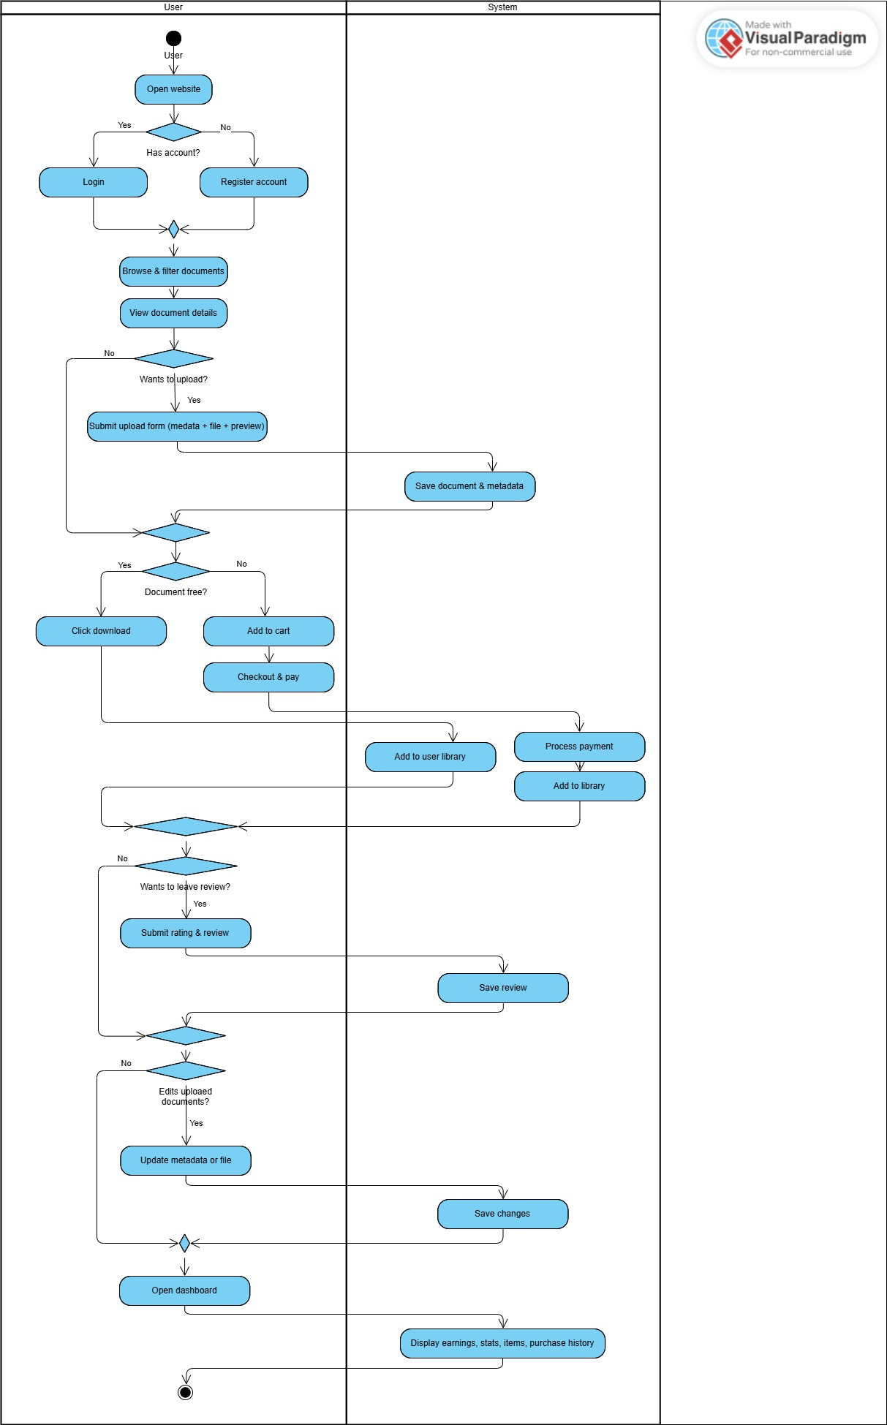
Figure 1. User Workflow Activity Diagram
User Functionalities:
- Login and Register: The system implements secure JWT-based authentication to manage user access, using hashed passwords and token-based sessions to ensure account security.
- Document Sorting: Advanced filters allow sorting by: Specific universities (all 237 Vietnamese institutions), Course codes/subject names, Price type (free/paid toggle), Popularity (download counts), Rating scores (1-5 stars with weighted averages)
- Post Documents/Courses: Users upload materials (PDF, Word (DOC/DOCX), Excel (XLS/XLSX), PowerPoint (PPT/PPTX), and plain text files under 100MB) through a multi-step form where they specify title, description, university/course association, and set pricing (free or fixed amount). Users must also upload at least one preview image to serve as the document thumbnail.
- Download/Buy Documents: Free resources are instantly downloadable, while paid content requires payment gateway integration. Purchased documents remain accessible indefinitely in the user's library.
- Review System: After downloading, users can leave: Star ratings (mandatory), Detailed text reviews (optional).
- Document Editing: Uploaders can modify titles and descriptions, adjust pricing, update the file and thumbnail image, and enable or disable the document. All updates preserve download counts.
- Shopping Cart: Supports 10-item bundles, and institutional coupon codes with real-time validation.
- Earnings Management: Content creators receive 90% of each sale (10% platform commission).
- Purchase History: A chronological log tracks all transactions with document details, payment amounts, timestamps, and review status and can be filtered by school, subject, and name.
- User Statistics: Dashboards show sellers' lifetime earnings, total money spent, and average rating, along with quick access to their uploaded items and purchase history.

3.1.1.2. Admin Functionalities
Figure 2 provides a high-level activity diagram of administrative operations, illustrating how administrators manage platform-wide data, maintain academic structure integrity, and ensure content quality. This diagram highlights the supervisory nature of the admin role and its impact on the platform’s operational stability.
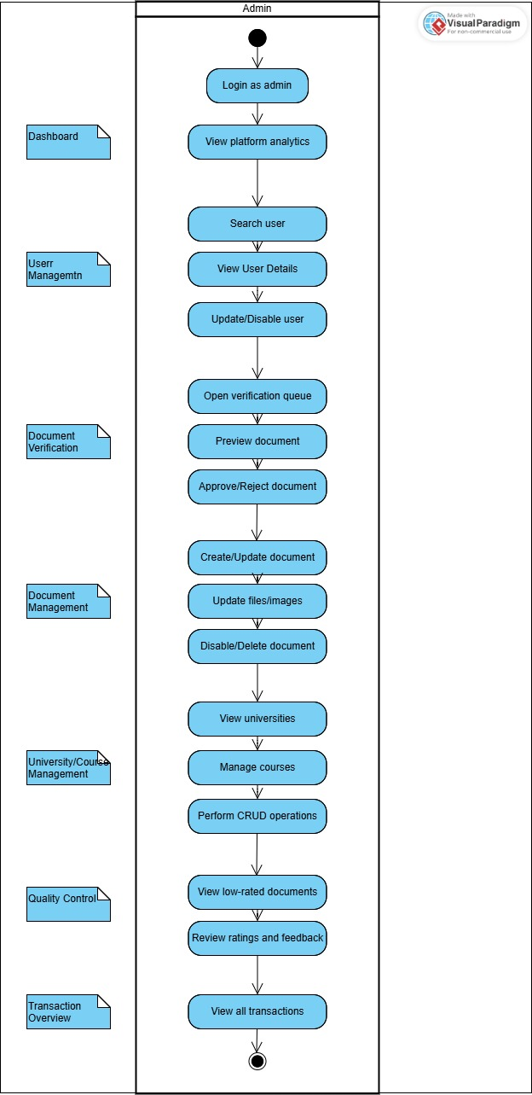
Figure 2. Admin Workflow Activity Diagram
Admin Functionalities:
- Platform Analytics: Administrators can access a centralized analytics dashboard displaying total sales aggregated by university, gross revenue (including platform commission calculations), document upload volumes, and the list of top-selling documents. This module provides a high-level overview of platform performance and academic activity trends.
- User Management (RUD): Admins have full control over user accounts, including the ability to view, update, and disable accounts that violate platform policies. The system includes a fast search function that allows administrators to locate specific users by name, enabling efficient user oversight.
- Document Verification: A dedicated verification interface allows admins to review newly uploaded documents using a built-in preview. For quality assurance, each document can be approved or rejected.
- Document Management (CRUD): Administrators can manage all existing documents on the platform. This includes creating institutional documents, updating metadata, replacing files, disabling content, or permanently removing documents that violate policies.
- University & Course Management: Admins can manage the academic structure of the platform by maintaining the list of universities and their associated courses. Selecting a university displays all related courses, and admins can perform full CRUD operations on both universities and course records.
- Quality Control: A dedicated interface lists all documents or reviews with ratings below 4 stars. Admins use this page to assess content quality, determine whether intervention is needed, and ensure consistent academic standards across the platform.
- Transaction Overview: Administrators can view all transactions made on the marketplace. Each entry includes details such as buyer information, purchased document, amount paid, and timestamp, enabling transparency and platform-wide financial monitoring.

3.1.2 Non-Functionalities
Non-functional requirements define the quality attributes of the platform, ensuring its reliability, performance, and usability.
      - Performance: The system must support 5,000 concurrent users during peak academic periods with sub-2-second response times for document searches and downloads. All pages should load within 3 seconds on 3G mobile networks.
      - Scalability: The architecture should allow horizontal scaling to accommodate 50% annual growth in users and content uploads without service degradation.
      - Security: User data and payment information must be encrypted using AES-256 standards. The platform will implement annual penetration testing and maintain 99.9% uptime for critical services.
      - Usability: First-time users should be able to upload/download documents.
      - Maintainability
        - Modular, clean code with version control via GitHub for easy maintenance.
        - Provide thorough system documentation for future updates.
These non-functional requirements ensure the platform is secure, reliable, and scalable while delivering a seamless experience for both customers and administrators. They provide a strong foundation for long-term performance and future enhancements.

3.1.3 Screen Flow Diagram
This part provides a detailed representation of the user navigation flow for both customer and admin roles within the document sharing website. The screen flow diagrams illustrate how users interact with the system, transitioning from one interface to another while performing specific tasks. These diagrams serve to visualize the step-by-step progression of actions, ensuring clarity in understanding the user experience and system functionality.
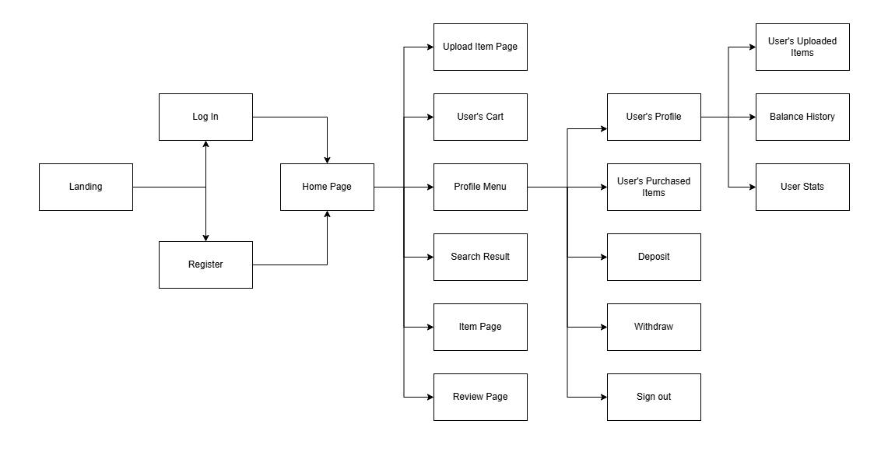
Figure 3. Customer screen flow
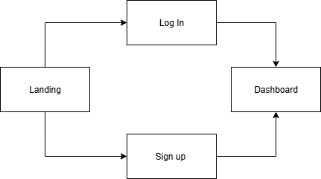
Figure 4. Administration screen flow (by authors)

Database
SQL Server was selected as the database management system for its reliability, scalability, and strong support for relational integrity. During development, the database schema underwent several iterations to better align with real system needs. This section focuses specifically on the final structure and the key improvements made from earlier versions.

3.2.1. Overview of Major Changes
During refinement of the system requirements, the database evolved from a simple e-commerce-style structure to a university-integrated academic content platform. The most significant changes include:
      - Introduction of academic hierarchy tables (University and Subject) to support institution-based filtering.
      - Replacement of generic product/media tables with document-centric tables, including:
        - Document
        - Document_Image
        - Document_File
      - Removal of unnecessary entities from the initial design (categories, products, orders in classic form).
      - Integration of quality-control mechanisms, such as review counts, average rating, and soft-deletion fields.
      - Addition of purchase tracking (User Purchase) to support analytics and contributor earnings.
      - Simplification of the cart system into a single Cart_Item table using a composite key.
These updates shifted the database from a typical online store model to a structure fully tailored for learning materials, contributor uploads, and institutional organization [8].

3.2.2. Final Database Schema

3.2.2.1. Database Diagram
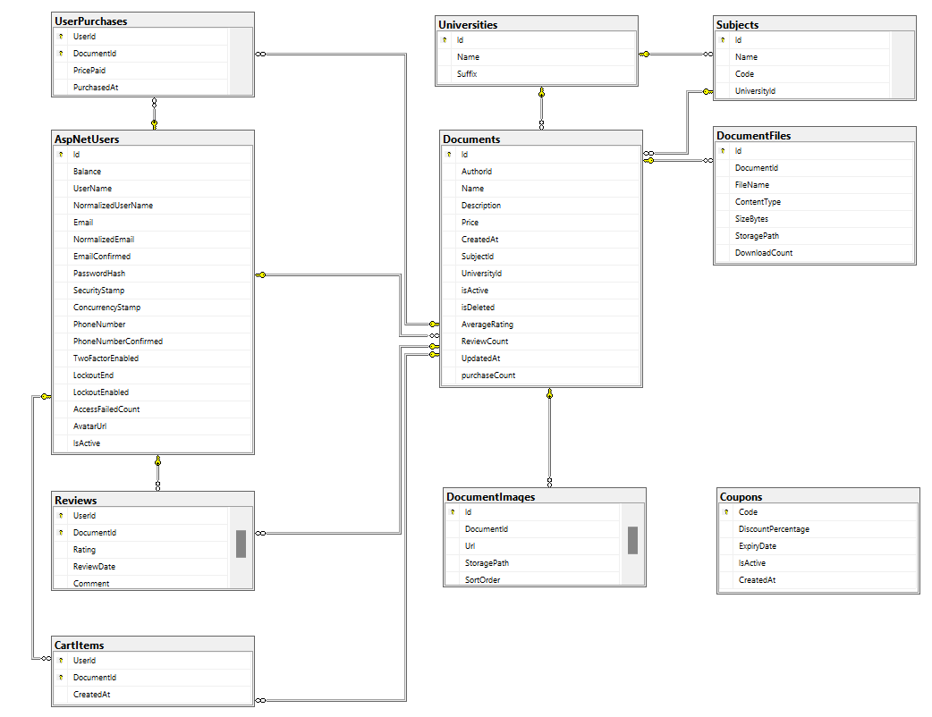
Figure 5. Database Diagram

3.2.2.2. Description of tables
- The Users table is the foundation of the database, storing essential user information for authentication, authorization, and profile management. It supports both mandatory and optional attributes, ensuring flexibility for a variety of use cases.

Table 1. User
No. | Field Name | Type | Description
1 | User_id | Int (auto increment) | Primary key
2 | Username | Varchar(100) | User name, Not null
3 | Password | Varchar(255) | Hashed password, Not null
4 | Email | Varchar(100) | User email, Not null, Unique
5 | Avatar URL | Varchar(255) | URL to user's profile image
6 | Role | Enum | Client, Admin
7 | Balance | Int | User's account balance in system credits
8 | Created_at | Timestamp
9 | Is_active | Boolean | Indicates if the account is active
- The Reviews table

Table 2. Review
No. | Field Name | Type | Description
1 | Review_id | Int (auto increment) | Primary key
2 | Document_id | Int | Document Id (foreign key), link to Document
3 | User_id | Int | User Id (foreign key), link to User
4 | Rating | TinyInt | Not null
5 | Comment | Text | User's written feedback
6 | Review_date | Timestamp | Date and time of review submission
- The University table stores institutional data with university_id as the primary key and name for university identification. This foundational table supports document categorization by academic origin.

Table 3. University
No. | Field Name | Type | Description
1 | University_id | Int (auto increment) | Primary key
2 | Name | Varchar(100) | Name of University
3 | Suffix | Varchar(100) | Suffix (e.g., campus name or abbreviation)
- The Subject table maintains subject catalog with subject_id as the primary key and name for discipline identification. Enables precise academic resource classification and filtering.

Table 4. Subject
No. | Field Name | Type | Description
1 | Subject_id | Int (auto increment) | Primary key
2 | University_id | Int | University Id (foreign key), link to University
3 | Name | Varchar(100) | Name of Subject
4 | Code | Varchar(50) | Code of the subject
- The Document table stores detailed information about the items offered within the system. It is a central component for inventory management and document cataloging.

Table 5. Document
No. | Field Name | Type | Description
1 | Document_id | Int (auto increment) | Primary key
2 | Name | Varchar(255) | Document title, Not null
3 | Description | Text | Detailed description of the document
4 | Purchase_count | Int | Number of items sold
5 | Price | Decimal(18,2) | Document price, Not null
6 | Created_at | Timestamp
7 | Is_active | Boolean | Indicate if the document is active
8 | Is_deleted | Boolean | Indicate if the document is soft-deleted
9 | Average_rating | Decimal(3,2) | The average number of all ratings
10 | Review_count | Int | The number of the document’s reviews
11 | Last_updated | Timestamp
12 | User_id | Int | Foreign key, link to User
13 | University_id | Int | Foreign key, link to University
14 | Subject_id | Int | Foreign key, link to Subject
- The Document Image table stores visual representations of documents with image_id as the primary key. The document_id foreign key associates each image with its corresponding document record, while image_url contains the path to the stored thumbnail or preview image. This table enables efficient document visualization across the platform's browsing interfaces. Key aspects:

Table 6. Document_Image
No. | Field Name | Type | Description
1 | Document_image_  id | Int (auto increment) | Primary key
2 | Document_id | Int | Foreign key, link to Document
3 | Url | Varchar (255) | The URl to the thumbnail
4 | Storage_path | Varchar(255) | Path to the stored file
5 | Sort_order | Int | The index of the thumbnail
- The Document_File table manages the metadata and storage details of files associated with documents. Each record represents a file linked to a document, enabling secure access, download tracking, and efficient file management across the platform. The document_file_id serves as the primary key, while the document_id foreign key connects each file to its corresponding document. Additional attributes capture file-specific information such as name, type, size, and storage location.
Table 7. Document File
No. | Field Name | Type | Description
1 | Document_file_id | Int(auto increment) | Primary Key
2 | Document_id | Int | Foreign key, links to Document
3 | File_name | Varchar(255) | Name of the uploaded file
4 | Content_type | Varchar(100) | Type of the file
5 | Size_bytes | Int | File size in bytes
6 | Storage_path | Varchar(255) | Path to the stored file
7 | Download_count | Int | Number of times the file has been downloaded
- The Orders table tracks and manages purchase transactions within the system, serving as a critical component for commerce and sales tracking.

Table 8. User Purchase
No. | Field Name | Type | Description
1 | Document_id | Int | Foreign key, links to Document
2 | User_id | Int | Foreign key, links to User
3 | Price_paid | Decimal(18,2) | Price when purchasing
4 | Purchased_Date | Date | Date of purchase creation
- The Cart_Item table tracks which documents users have added to their shopping carts. Each entry represents a unique pairing of a user and a document, enabling personalized cart management and streamlined checkout processes. The table uses a composite key consisting of user_id and document_id to ensure each document appears only once per user's cart.

Table 9. Cart Item
No. | Field Name | Type | Description
1 | User_id | Int | Foreign key, links to User
2 | Document_id | Int | Foreign key, links to Document

CHAPTER 4. EXPERIMENT AND DISCUSSION
In chapter 4, we present the evaluation and analysis of the website’s performance and functionality. It discusses the results of testing processes, highlights technical and user experience challenges encountered, and analyzes the outcomes against the project’s objectives. Through critical reflection, this section explores areas for improvement and assesses the practical implications of the implemented features.

Installation Environment
- NET SDK: ASP.NET Core 8 – Framework for building RESTful APIs and web applications.
- Development Tools: Visual Studio 2022 – Primary IDE used for coding, debugging, and managing project files.
- Programming Languages and Frameworks:
  - Frontend: TypeScript 5.1.6 with React 18.2.0
  - Styling: Tailwind CSS 3.3.3 with PostCSS 8.4.28
  - Build Tools: Vite 4.4.5 for optimized bundling
- Database: SQL Server – Used as the relational database for managing user accounts, documents, and orders efficiently.
- Browsers for Testing: Google Chrome
- Version Control: Git and GitHub: Utilized for source code management, version control, and seamless team collaboration.

Results and Discussion
This section presents the implemented features of the academic document-sharing platform and analyzes the evolution of the interface from the initial prototype to the final system. Given that the system serves two distinct user groups—regular users and administrators—the discussion is organized accordingly. Key workflows and interface design decisions are illustrated with reference to screenshots of the final system.

4.2.1 User Interface and User-Side Functionalities
The user interface (UI) was redesigned to enhance usability, clarity, and academic relevance. Compared to the initial frontend prototype, the final version improved navigation flow, visual structure, and filtering accuracy, enabling a more intuitive document discovery experience.

4.2.1.1. User Home Page
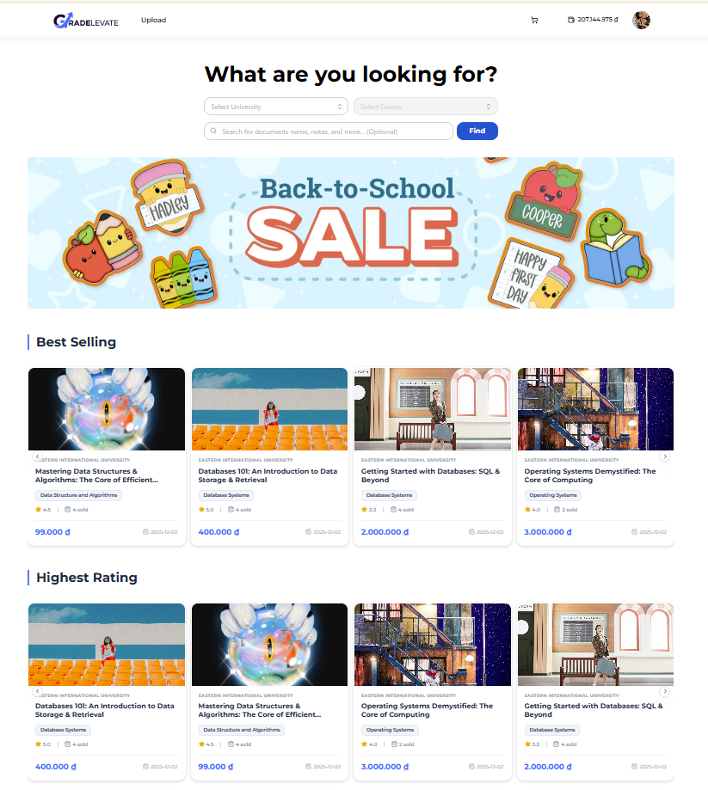
Figure 6. Home Page Function
- The homepage serves as the primary entry point for users, displaying academic documents in a structured card-based layout. Sections such as Best Selling and Highest Rated guide users toward high-quality and popular resources.
- Core functionalities, including document cards, search bar, sorting categories, and document previews, remain unchanged from the original prototype, ensuring continuity in user experience.
- Minor visual refinements were applied to improve aesthetics and readability:
        - Adjusted font sizes for enhanced clarity
        - Updated color palette for titles, prices, and buttons
These changes primarily enhance aesthetics and visual clarity without altering the original navigation flow or homepage logic.

4.2.1.2. Document Browsing & Filtering
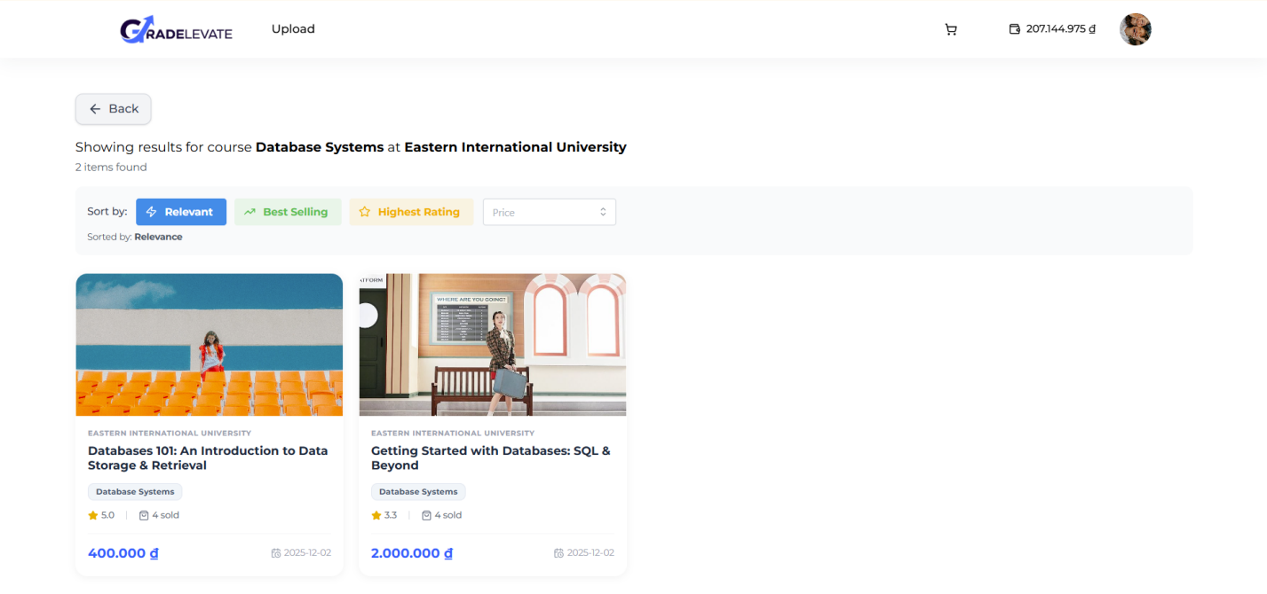
Figure 7. Browsing and Filter Function
- The browsing and filtering interface allows users to discover academic documents based on university, subject, rating, popularity, and price.
- Documents are displayed with consistent metadata, including titles, prices, and ratings, enabling efficient comparison.
- The interface preserves the original layout, offering intuitive navigation and logical presentation of filter options.
- Functional behavior remains unchanged from the initial version.

4.2.1.3. Document Details View

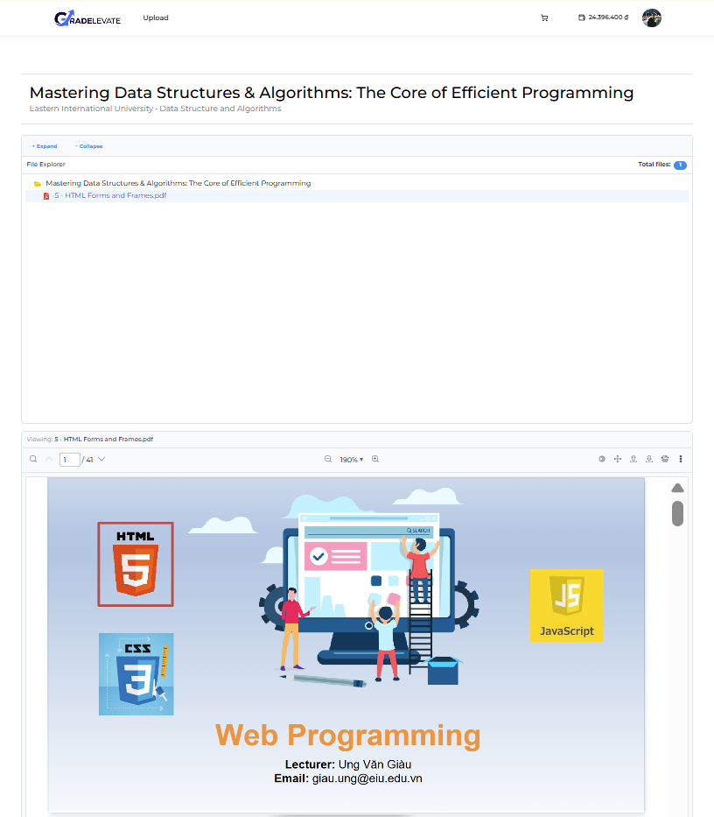
Figure 8. Document Details View
- The document details page provides comprehensive information about each academic resource, including document title, associated university and subject, preview images, and uploader information.
- The functional structure and interaction flow are consistent with the original design, ensuring clarity and accessibility of relevant academic information.

4.2.1.4. Upload Document View
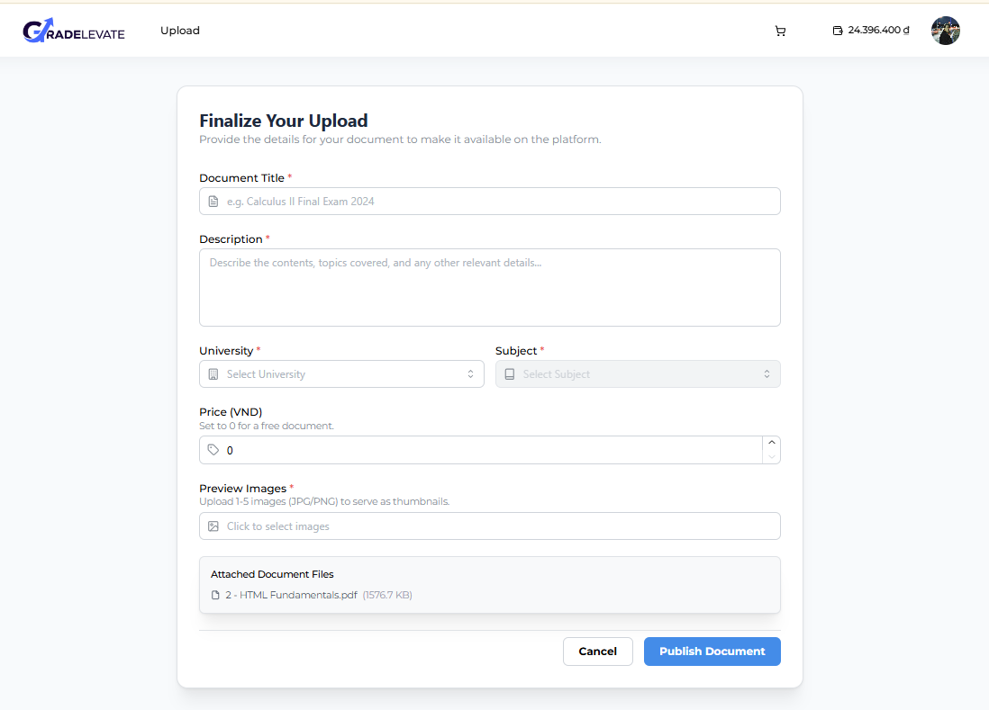
Figure 9. Upload Document View
- This multi-step interface enables contributors to upload documents, assign academic classifications, upload preview images, and set prices.
- Functional structure and workflow are preserved from the original prototype.
4.2.2. Administrator Functionalities
The administrator interface is divided into specialized modules designed for moderation, academic structure management, and system oversight. Several of these modules were newly introduced or expanded during development.

4.2.2.1. Analysis View
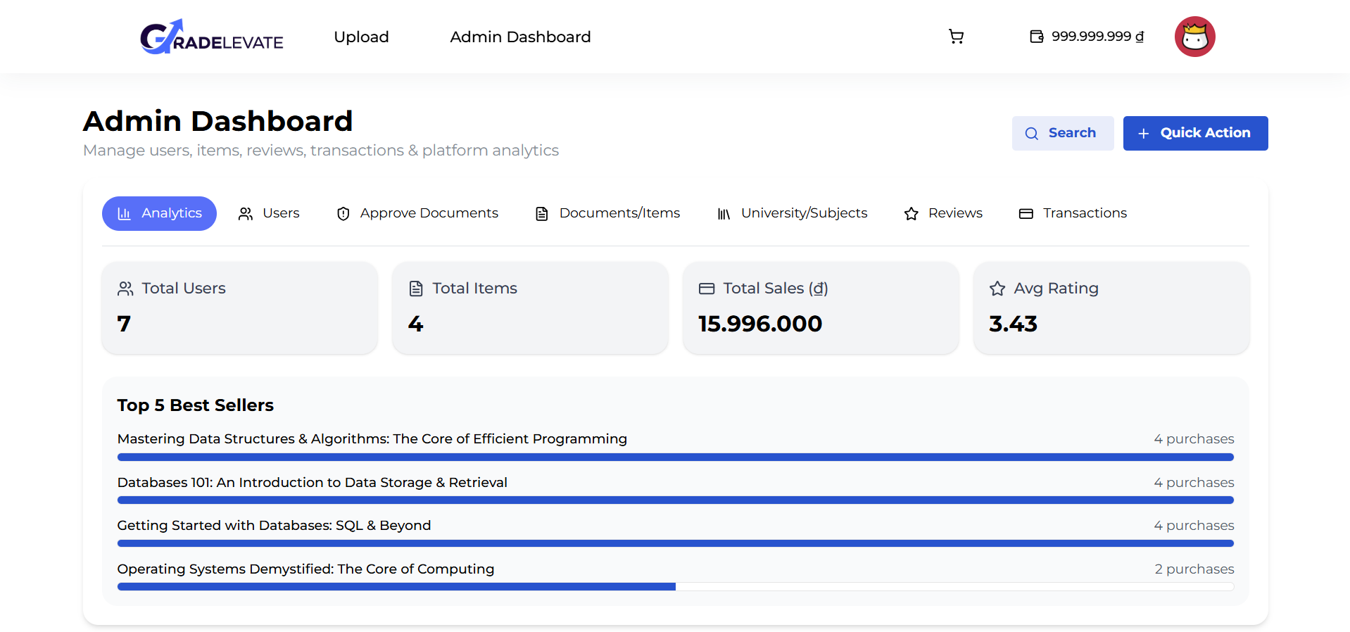
Figure 10. Analysis View
- The analytics dashboard provides an overview of platform activity, including total sales, top-selling documents, upload statistics, and revenue distribution.
- The analytics layout and metrics remain the same as in the original prototype.
4.2.2.2. User Management View
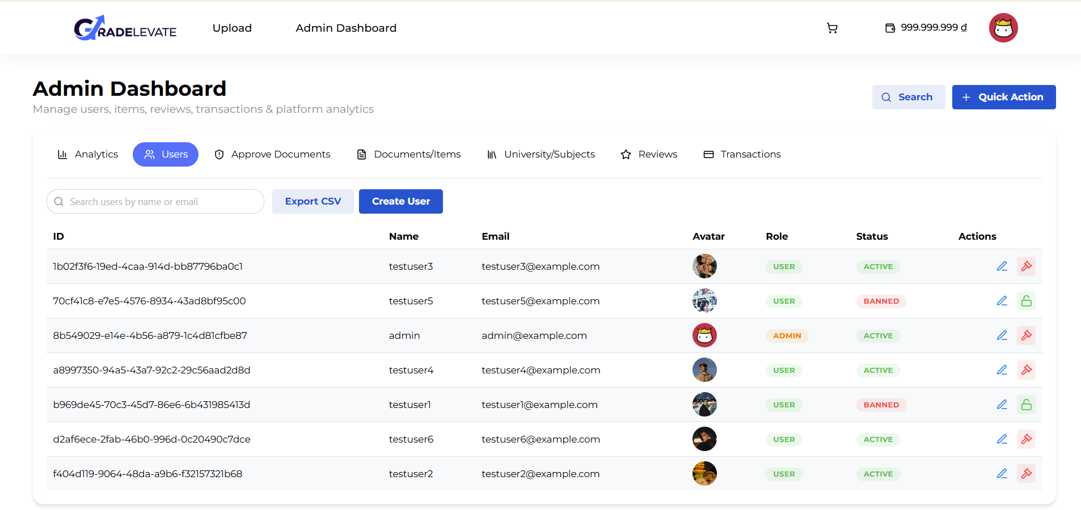
Figure 11. User Management
- This module allows administrators to manage all user accounts, including role assignment, account activation/deactivation, and user information review.
- Key enhancements:
+ Added role management (client, contributor, admin).
+ Introduced account activation/deactivation toggle
4.2.2.3. Approving Document Management
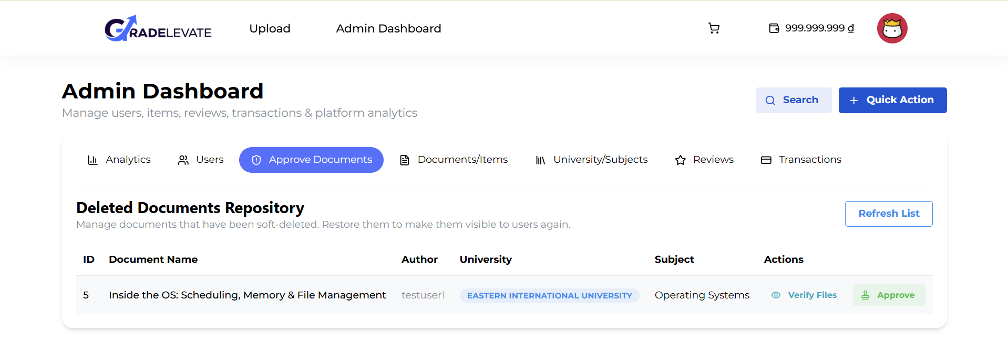
Figure 12. Approving Document Management
- A verification interface enables administrators to review newly uploaded documents prior to approval.
- Key enhancements:
+ New module introduced, absent in the original system
+ Preview capability and approve/reject workflow
4.2.2.3. Document Management
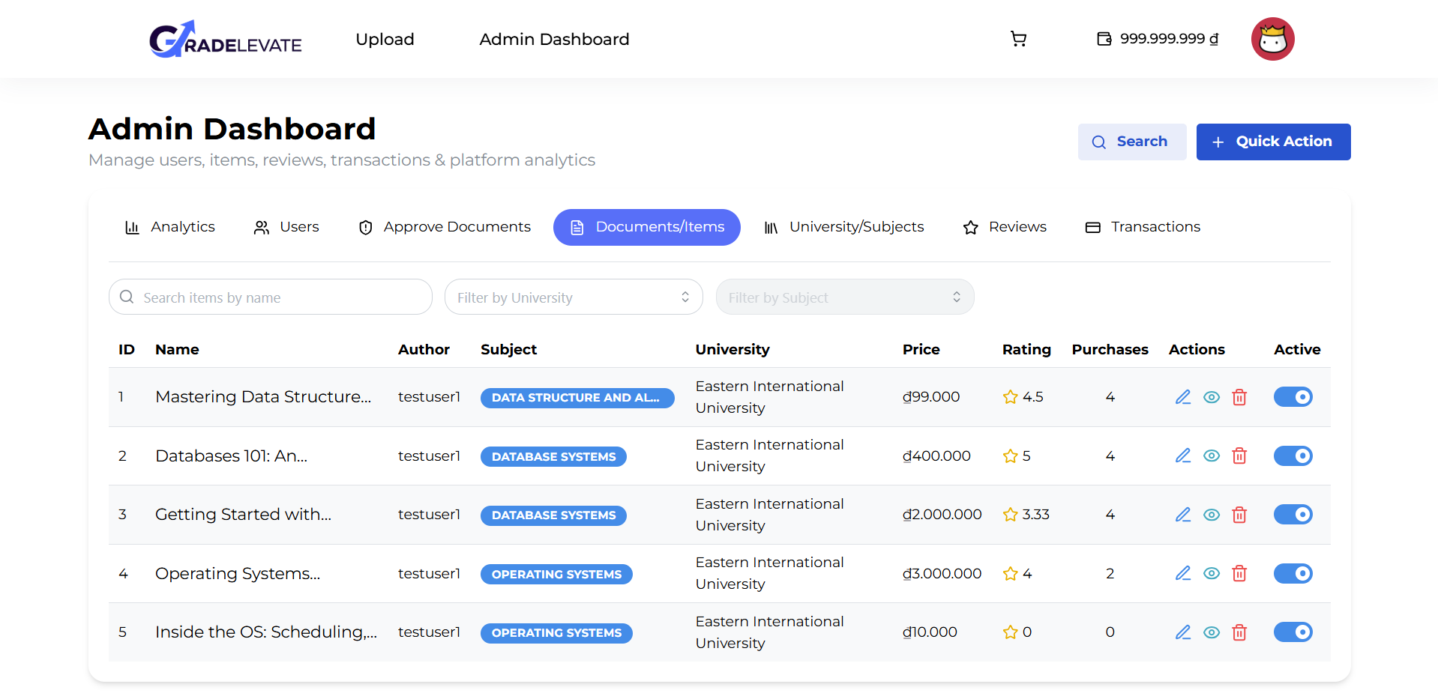
Figure 13. Document Management
- Administrators have full CRUD (Create, Read, Update, Delete) control over academic documents.
- Key enhancements:
+ Built-in document preview feature for direct content review
+ Activate/inactivate toggle to control document visibility without deletion
4.2.2.3. University Management
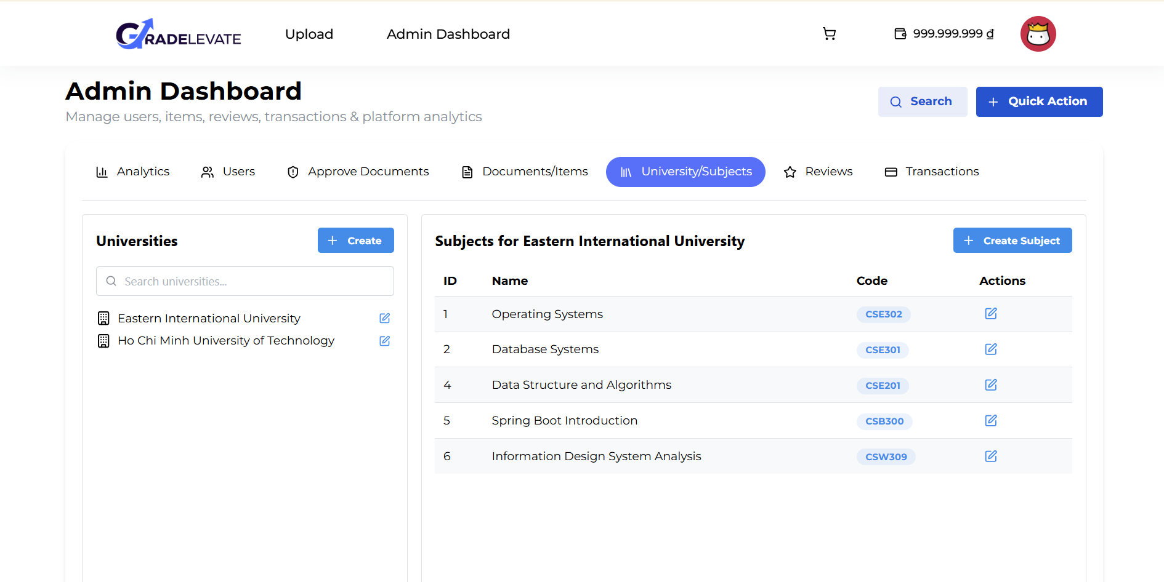
Figure 14. University Management
- This module manages the platform’s academic structure, enabling CRUD operations on universities and subjects, with quick search functionality.
- Key enhancements:
+ Newly introduced module
+ Hierarchical model: one university → multiple subjects
4.2.2.3. Review Management
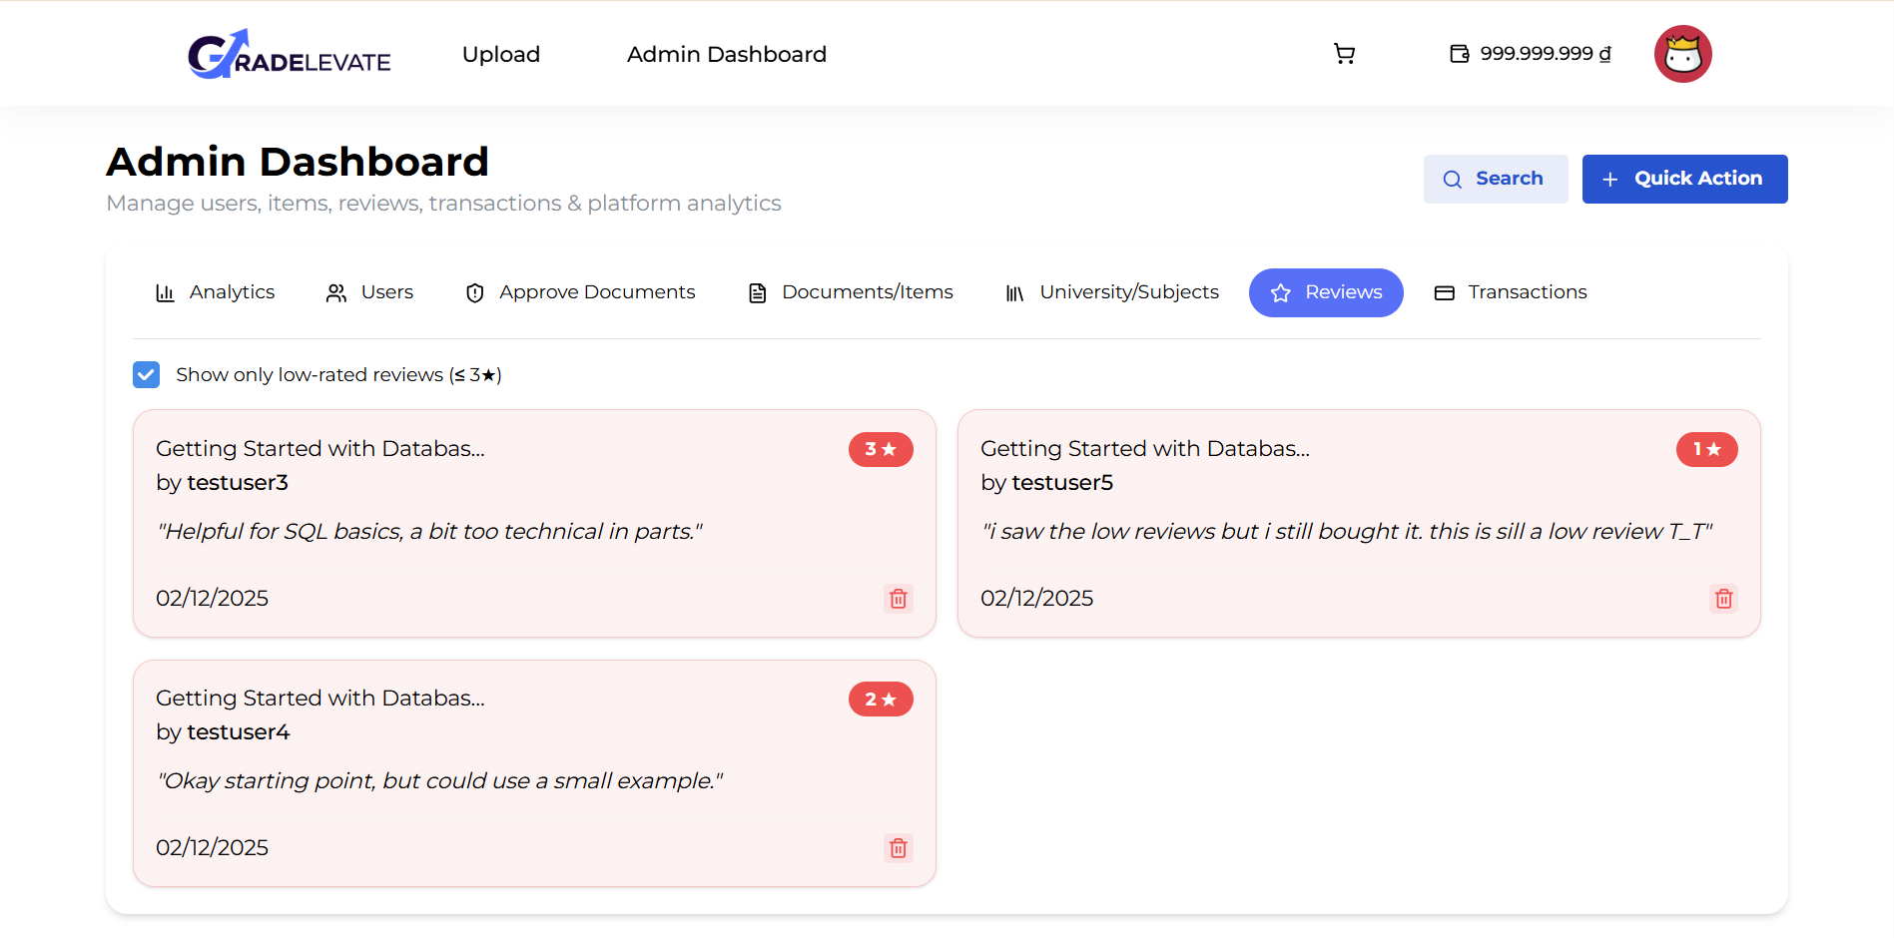
Figure 15. Review Management
- Displays all reviews and highlights low-rated content (below 4 stars) for quality control.
- Only minor visual refinements were implemented, including font size adjustments and updated color palette for improved readability.
4.2.2.3. Transaction Management
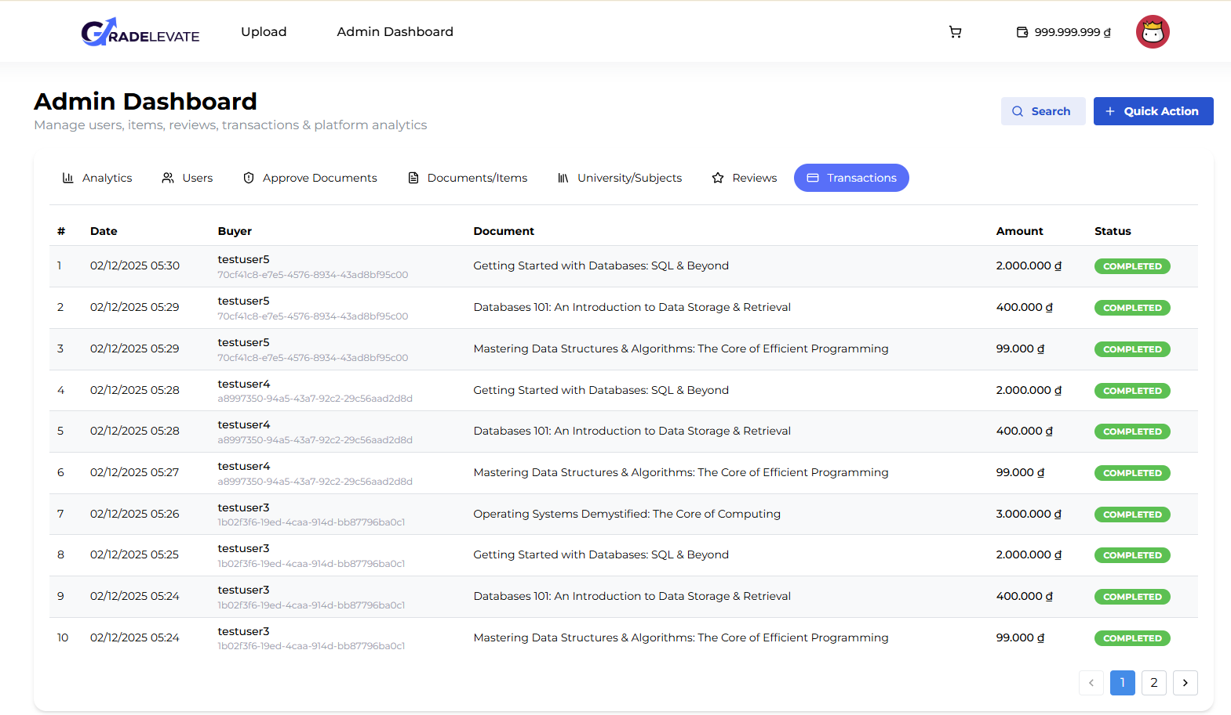
Figure 16. Transaction Management
- This page allows administrators to view all purchase records including buyer, document, amount paid, and timestamp.
- Only minor visual refinements were implemented to improve readability and aesthetic consistency.

CHAPTER 5. CONCLUSION AND FUTURE WORKS

Conclusion
In conclusion, the academic document-sharing platform has been successfully developed with full implementation of essential functionalities, including document browsing, filtering, uploading, and transaction processing. The platform leverages modern development tools and frameworks, including ReactJS for the frontend, ASP.NET Core for the backend, SQL Server for database management, and Git/GitHub for version control, which collectively improved the development workflow and system reliability.
Through this project, a complete web application was built from scratch, incorporating user authentication, role-based access (Student, Contributor, Administrator), and seamless interaction between frontend and backend components via RESTful APIs. Core features, including document management, user profiles, reviews, and transaction tracking, are fully operational and integrated with the database.
The development process presented challenges in areas such as complex state management, dynamic form handling, file previews, and backend authorization. Addressing these challenges enhanced our technical skills, problem-solving ability, and understanding of full-stack development principles. Continuous testing and iterative improvements ensured platform stability, security, and a user-friendly interface.
This project represents not only a completed platform but also a significant milestone in developing practical full-stack development expertise, combining front-end usability with backend robustness and system reliability.
While the Document Sharing Management System has achieved its core objectives, several limitations remain. First, the platform does not yet support a refund mechanism for purchased documents. Users who encounter issues such as accidental purchases or dissatisfaction with content have no way to request reimbursement, which may reduce trust and satisfaction. Second, the system currently lacks advanced search optimization and recommendation features. Although filtering by university, subject, and price is available, there is no intelligent recommendation engine to suggest relevant materials based on user behavior or academic needs. This limitation can make it harder for students to quickly discover the most useful resources. Together, these gaps highlight areas where future development is needed to improve fairness, usability, and personalization for a broader user base.

Future works
Building on the current foundation, future development phases aim to expand the platform’s functionalities, improve user experience, and enhance system scalability. Key areas for future work include:
- AI-Powered Recommendations: Implement machine learning models to analyze user behavior and document usage patterns, providing personalized content suggestions to improve discovery and engagement.
- Expanded Payment Integration: Add support for multiple payment gateways, including PayPal, Stripe, and ZaloPay, to accommodate domestic and international users and facilitate flexible premium content purchases.
- Cloud Deployment and Scalability: Migrate the platform to cloud infrastructure (e.g., Microsoft Azure, AWS, or GCP) and employ containerization with Docker and orchestration via Kubernetes to support high concurrency, automated scaling, and high availability.
- AI Chatbox with RAG (Retrieval-Augmented Generation): Develop an AI-powered chatbox to provide context-aware guidance, assist in document search, answer queries, and enhance overall platform navigation.

REFERENCES
- Smith, J. (2020). Web Application Scalability in Education. Journal of Computing Studies.
- Tran, L. (2019). Digital Learning in Vietnam. Asian Education Review.
- Brown, A. (2021). Agile Development for Student Platforms. Software Engineering Today.
- Nguyen, P. (2022). Secure Authentication in Academic Systems. International Journal of Cybersecurity.
- World Bank. (2023). EdTech for Emerging Markets Framework.
- Johnson, M. (2021). ASP.NET Core for Scalable APIs. Software Architecture Quarterly.
- Chen, Y. (2019). User Experience in Document Systems. EdTech Usability Studies.
- Garcia, S. (2022). Database Design for Academic Platforms. Data Systems Review.
- Pham, T. (2023). Future of Resource Sharing in Universities. Higher Education Technology Journal.
- Nguyen, T. et al. (2023). Frontend Architectures for EdTech in Southeast Asia.
- Facebook Research. (2022). Performance Benchmarks for React in Low-Bandwidth Environments.
- IEEE. (2023). Usability Patterns in Educational Single-Page Applications.
- Frost, B. (2016). Atomic Design Methodology.
- UNESCO. (2022). Digital Education Performance Standards for Developing Nations.

